D-311 Managing Stress

Summary:
This unit will focus on recognizing stress an IADP may encounter and how to respond to stress and where to find support.

Course Objectives:
By the end of this course students will be able to:
- Identify the three categories of stress.
- How to respond effectively to stressful situations.
- Know where to turn for support.

Course at a Glance:
Topics | Method | Approx. Time
Define Stress | Presentation / Group Presentation. | 20 Minutes
List the three categories of stressors | Presentation / Group Presentation. | 20 Minutes
Describe techniques for responding effectively to stress | Presentation / Group Presentation. | 20 Minutes
Identify support resources | Presentation / Group Presentation. | 20 Minutes
Exercise | Group Exercise | 40 Minutes
Total Time |  | Total 2 Hours

Preparation:
Ensure access to a computer/laptop and the Power Point. Students should have access to the slides in the Wildland Fire Learning Portal.

Course Materials:

Classroom:
- Ability to display images and video on large screen.

Slide 1
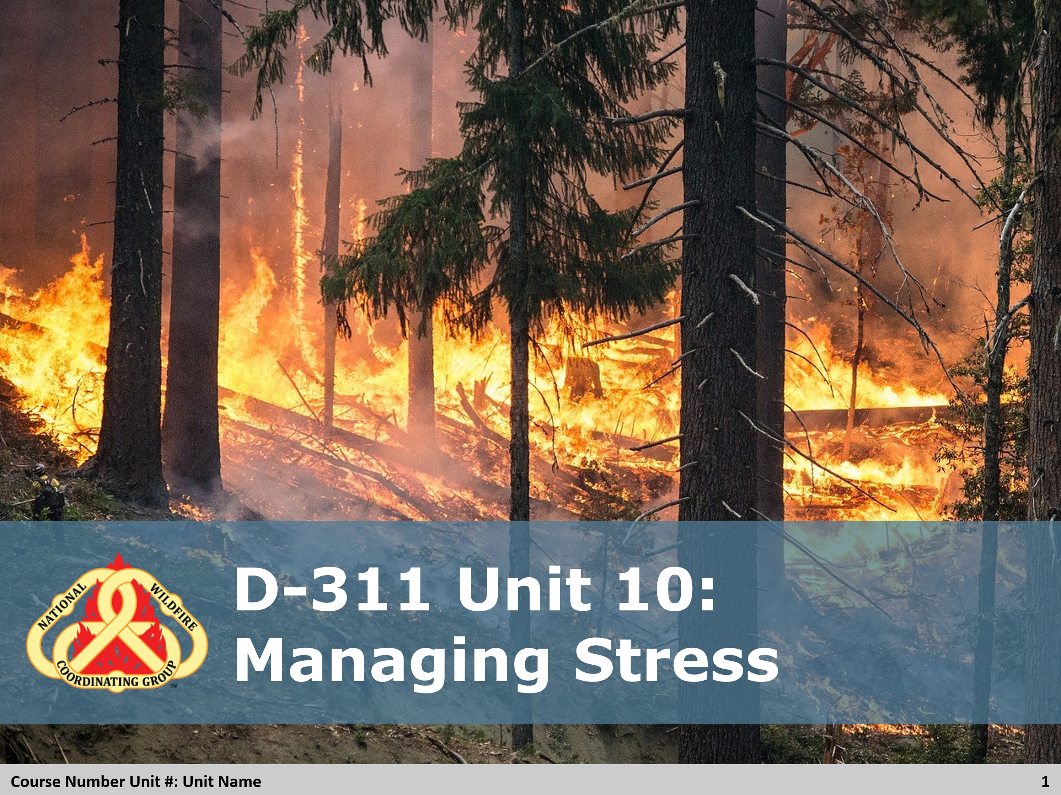

Slide 2
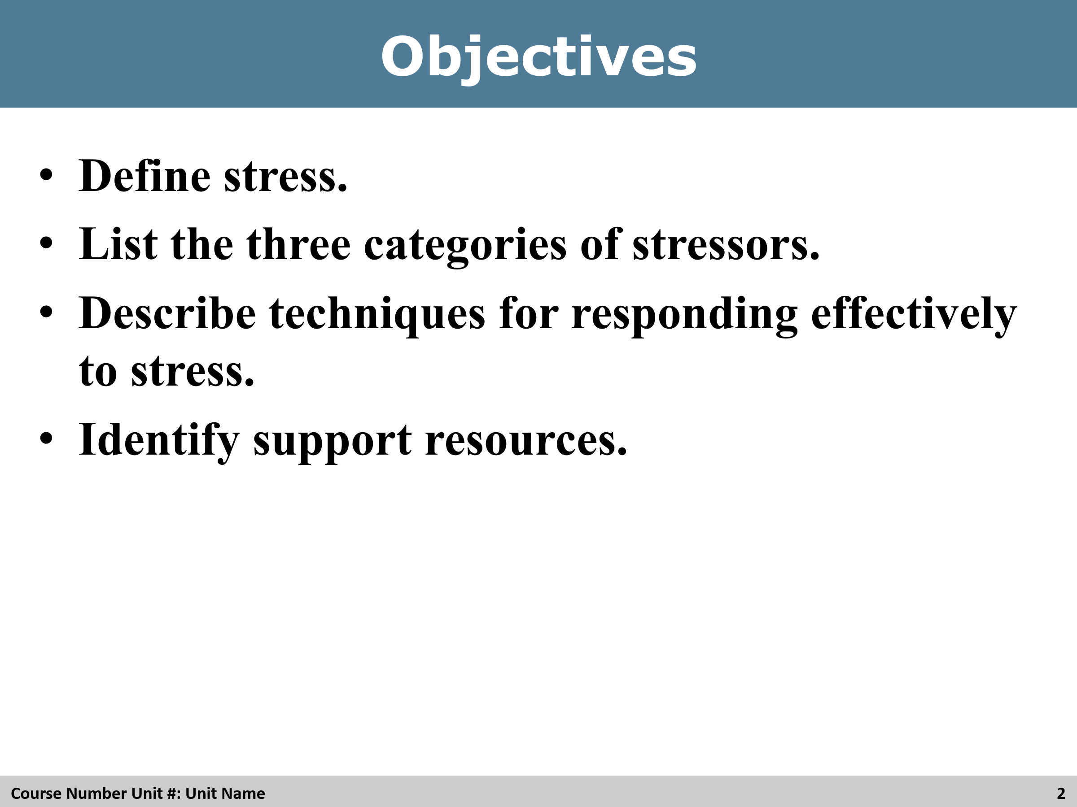
Review
Review the objectives with the students

Slide 3
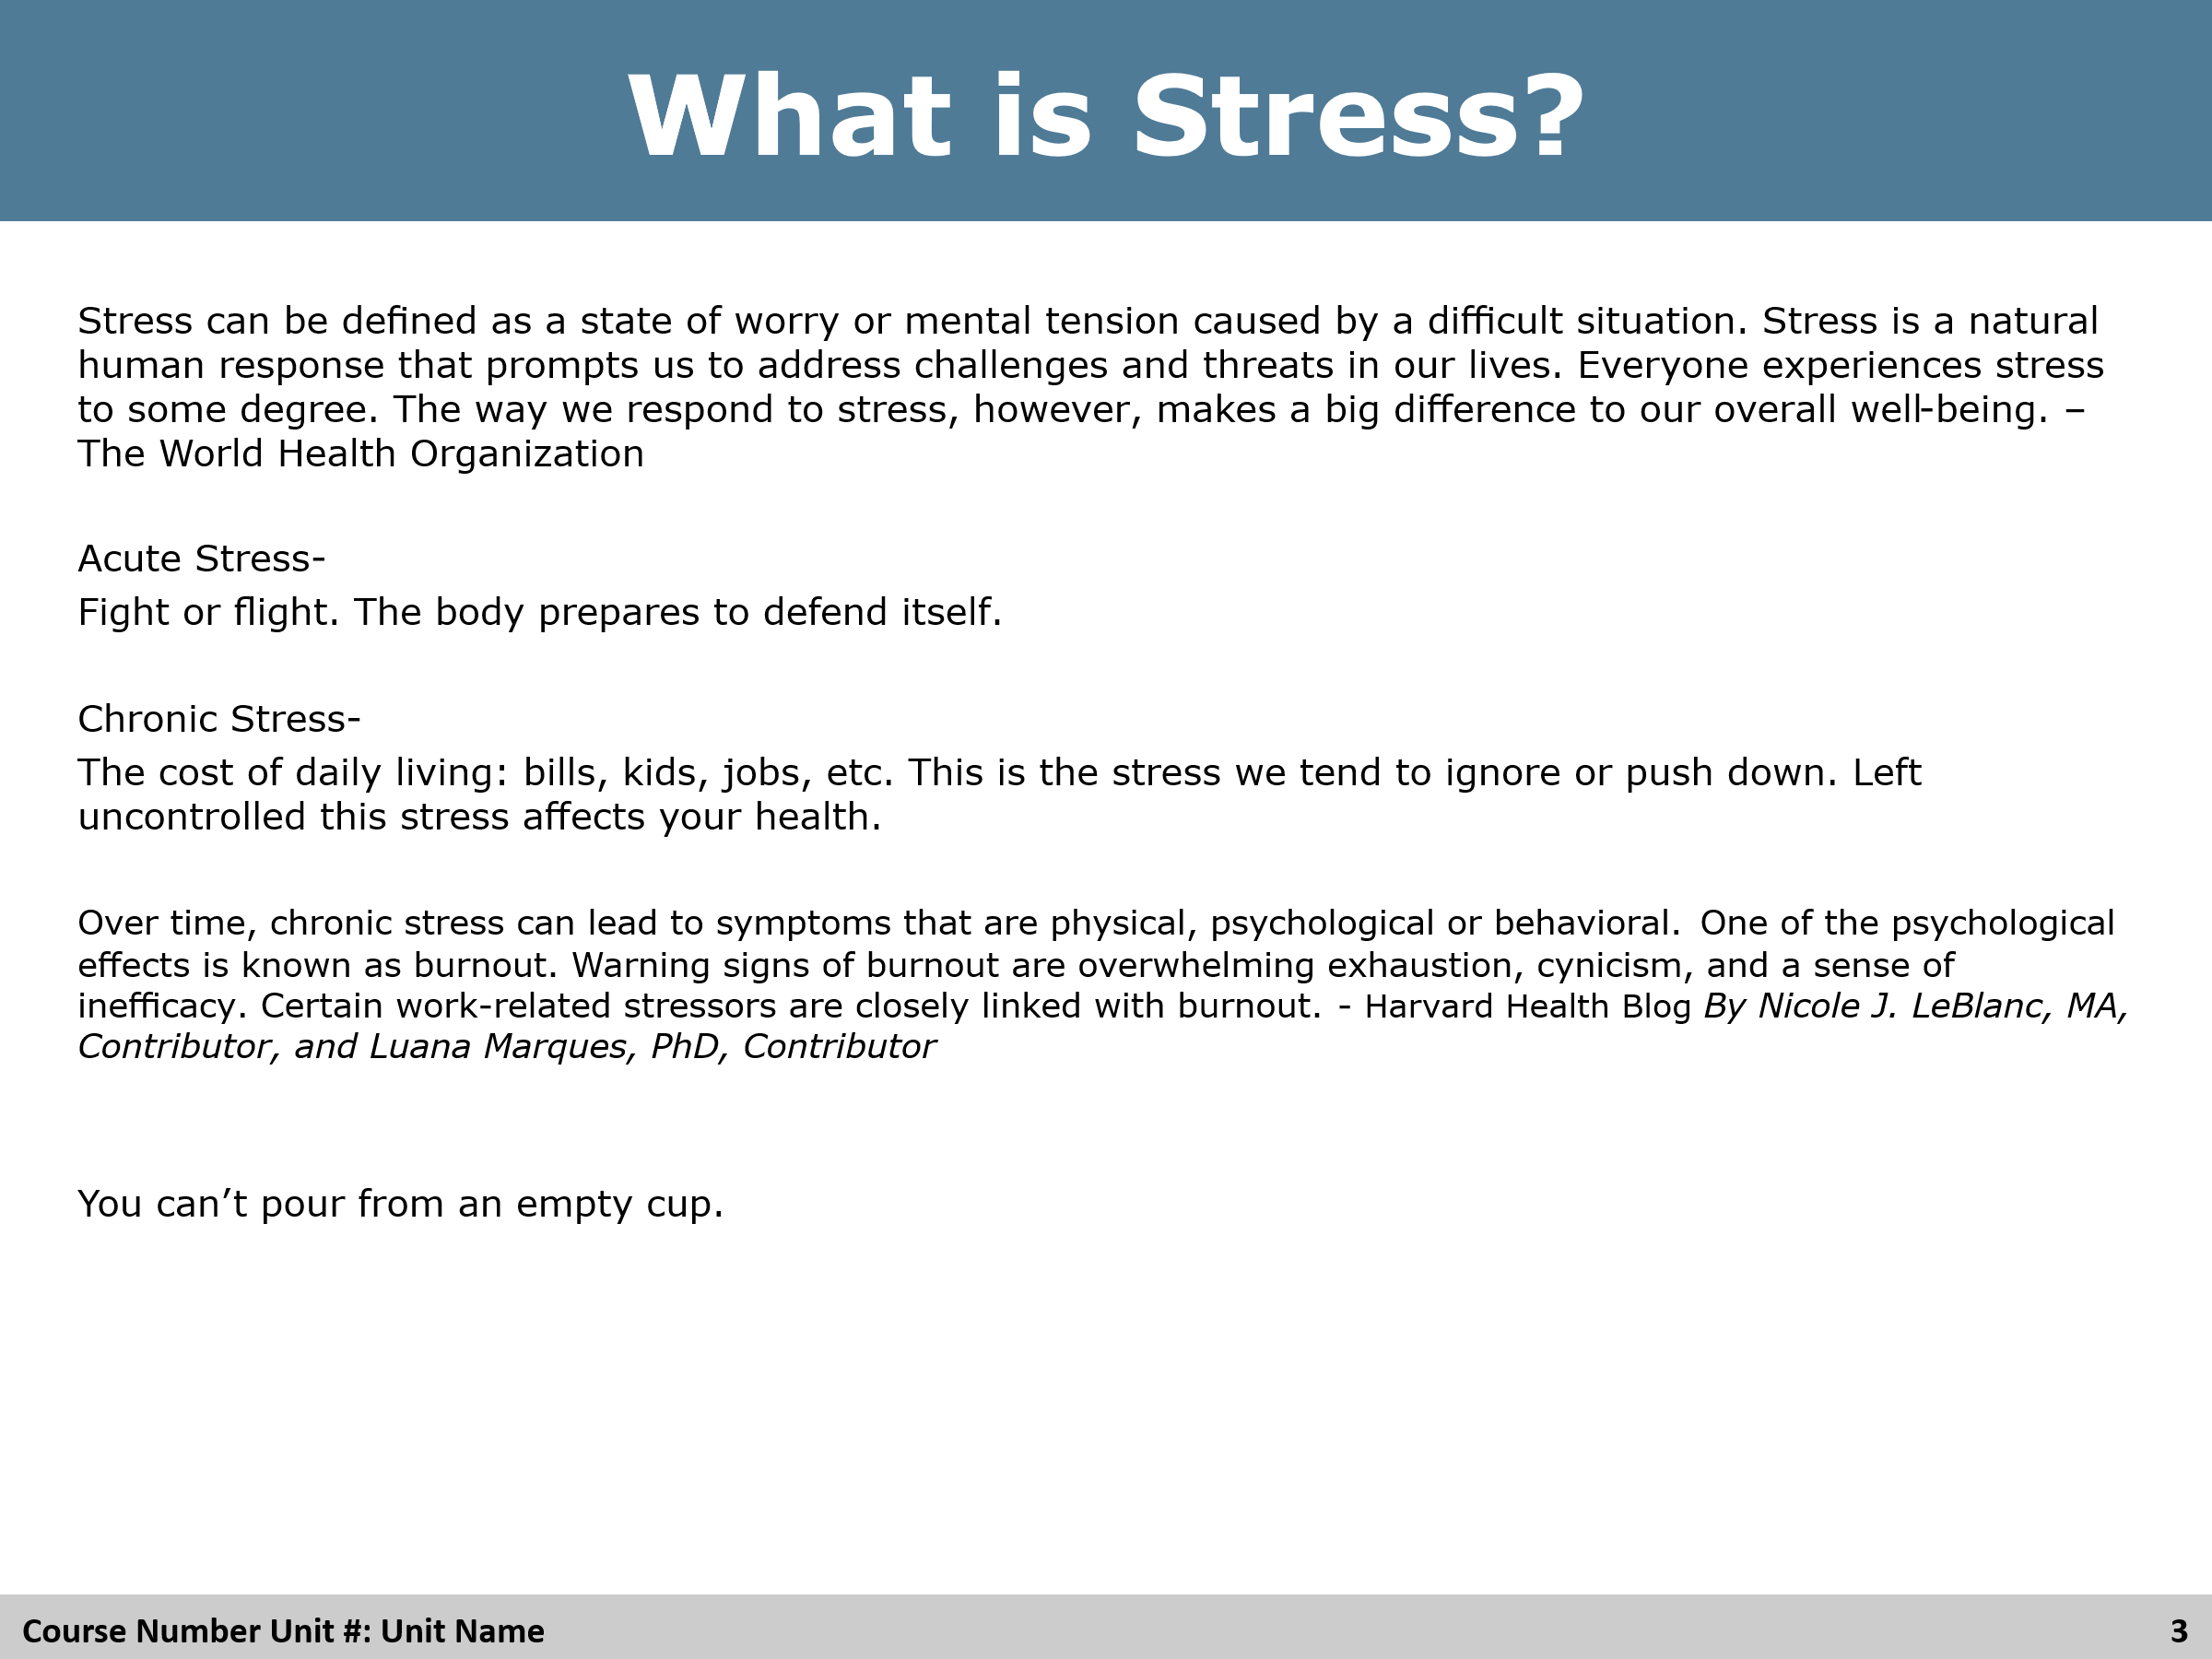
Review
Ask students if the know the three categories of stress, then present them on the slide.

Slide 4
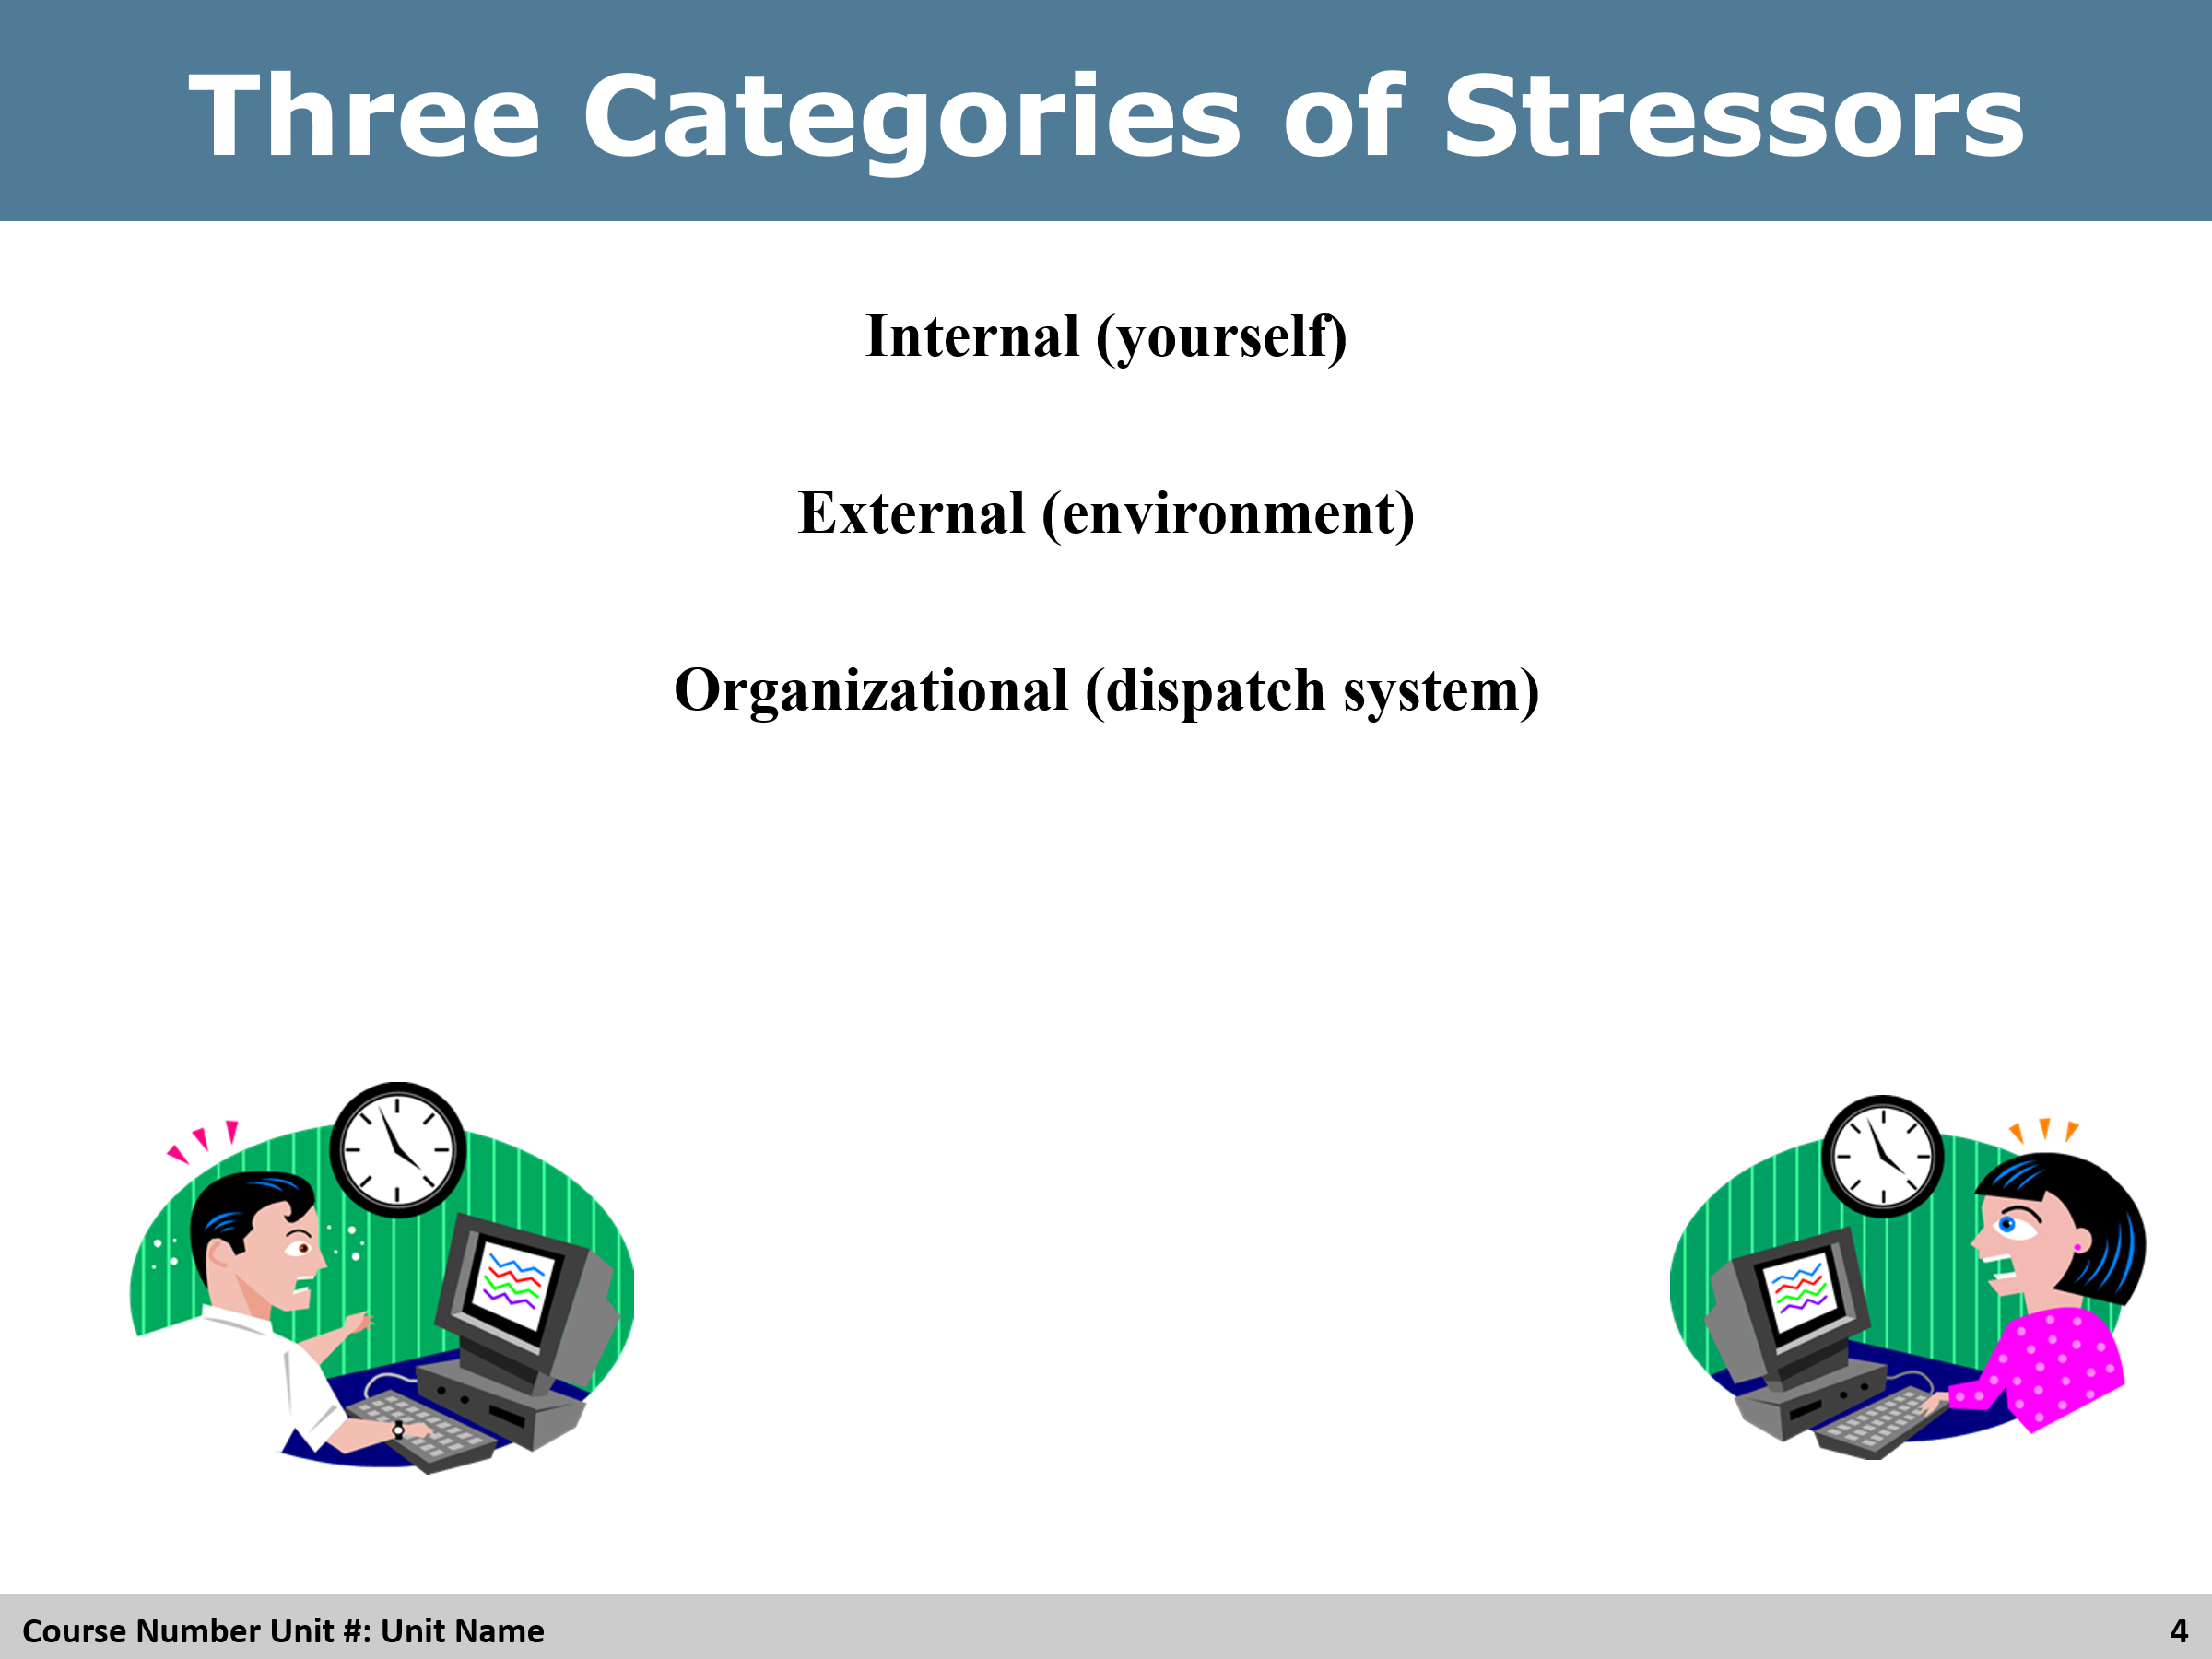

Review
Review with the students. Ask if they can name other examples.

Slide 5
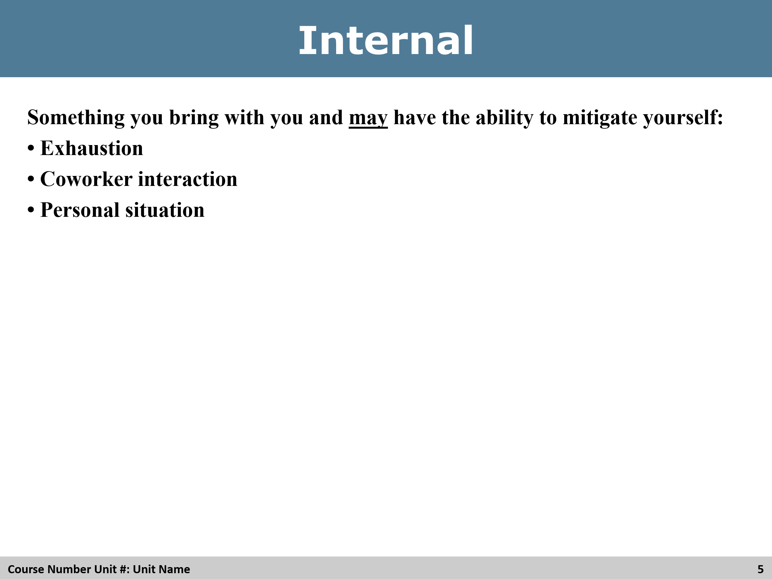

Review
Review with the students. Ask if they can name other examples.

Slide 6
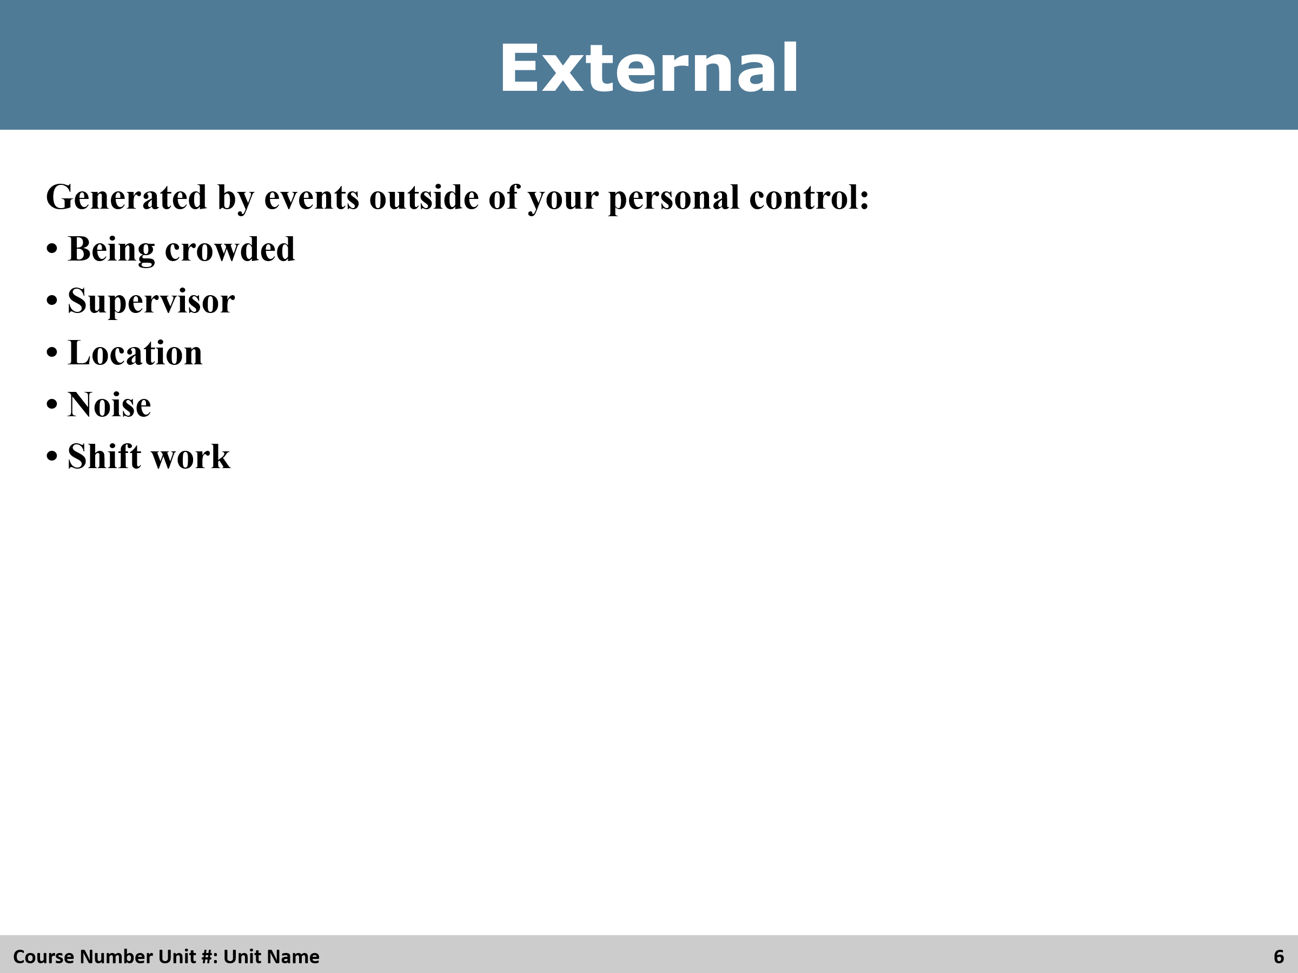

Review
Review with the students. Ask if they can name other examples.

Slide 7
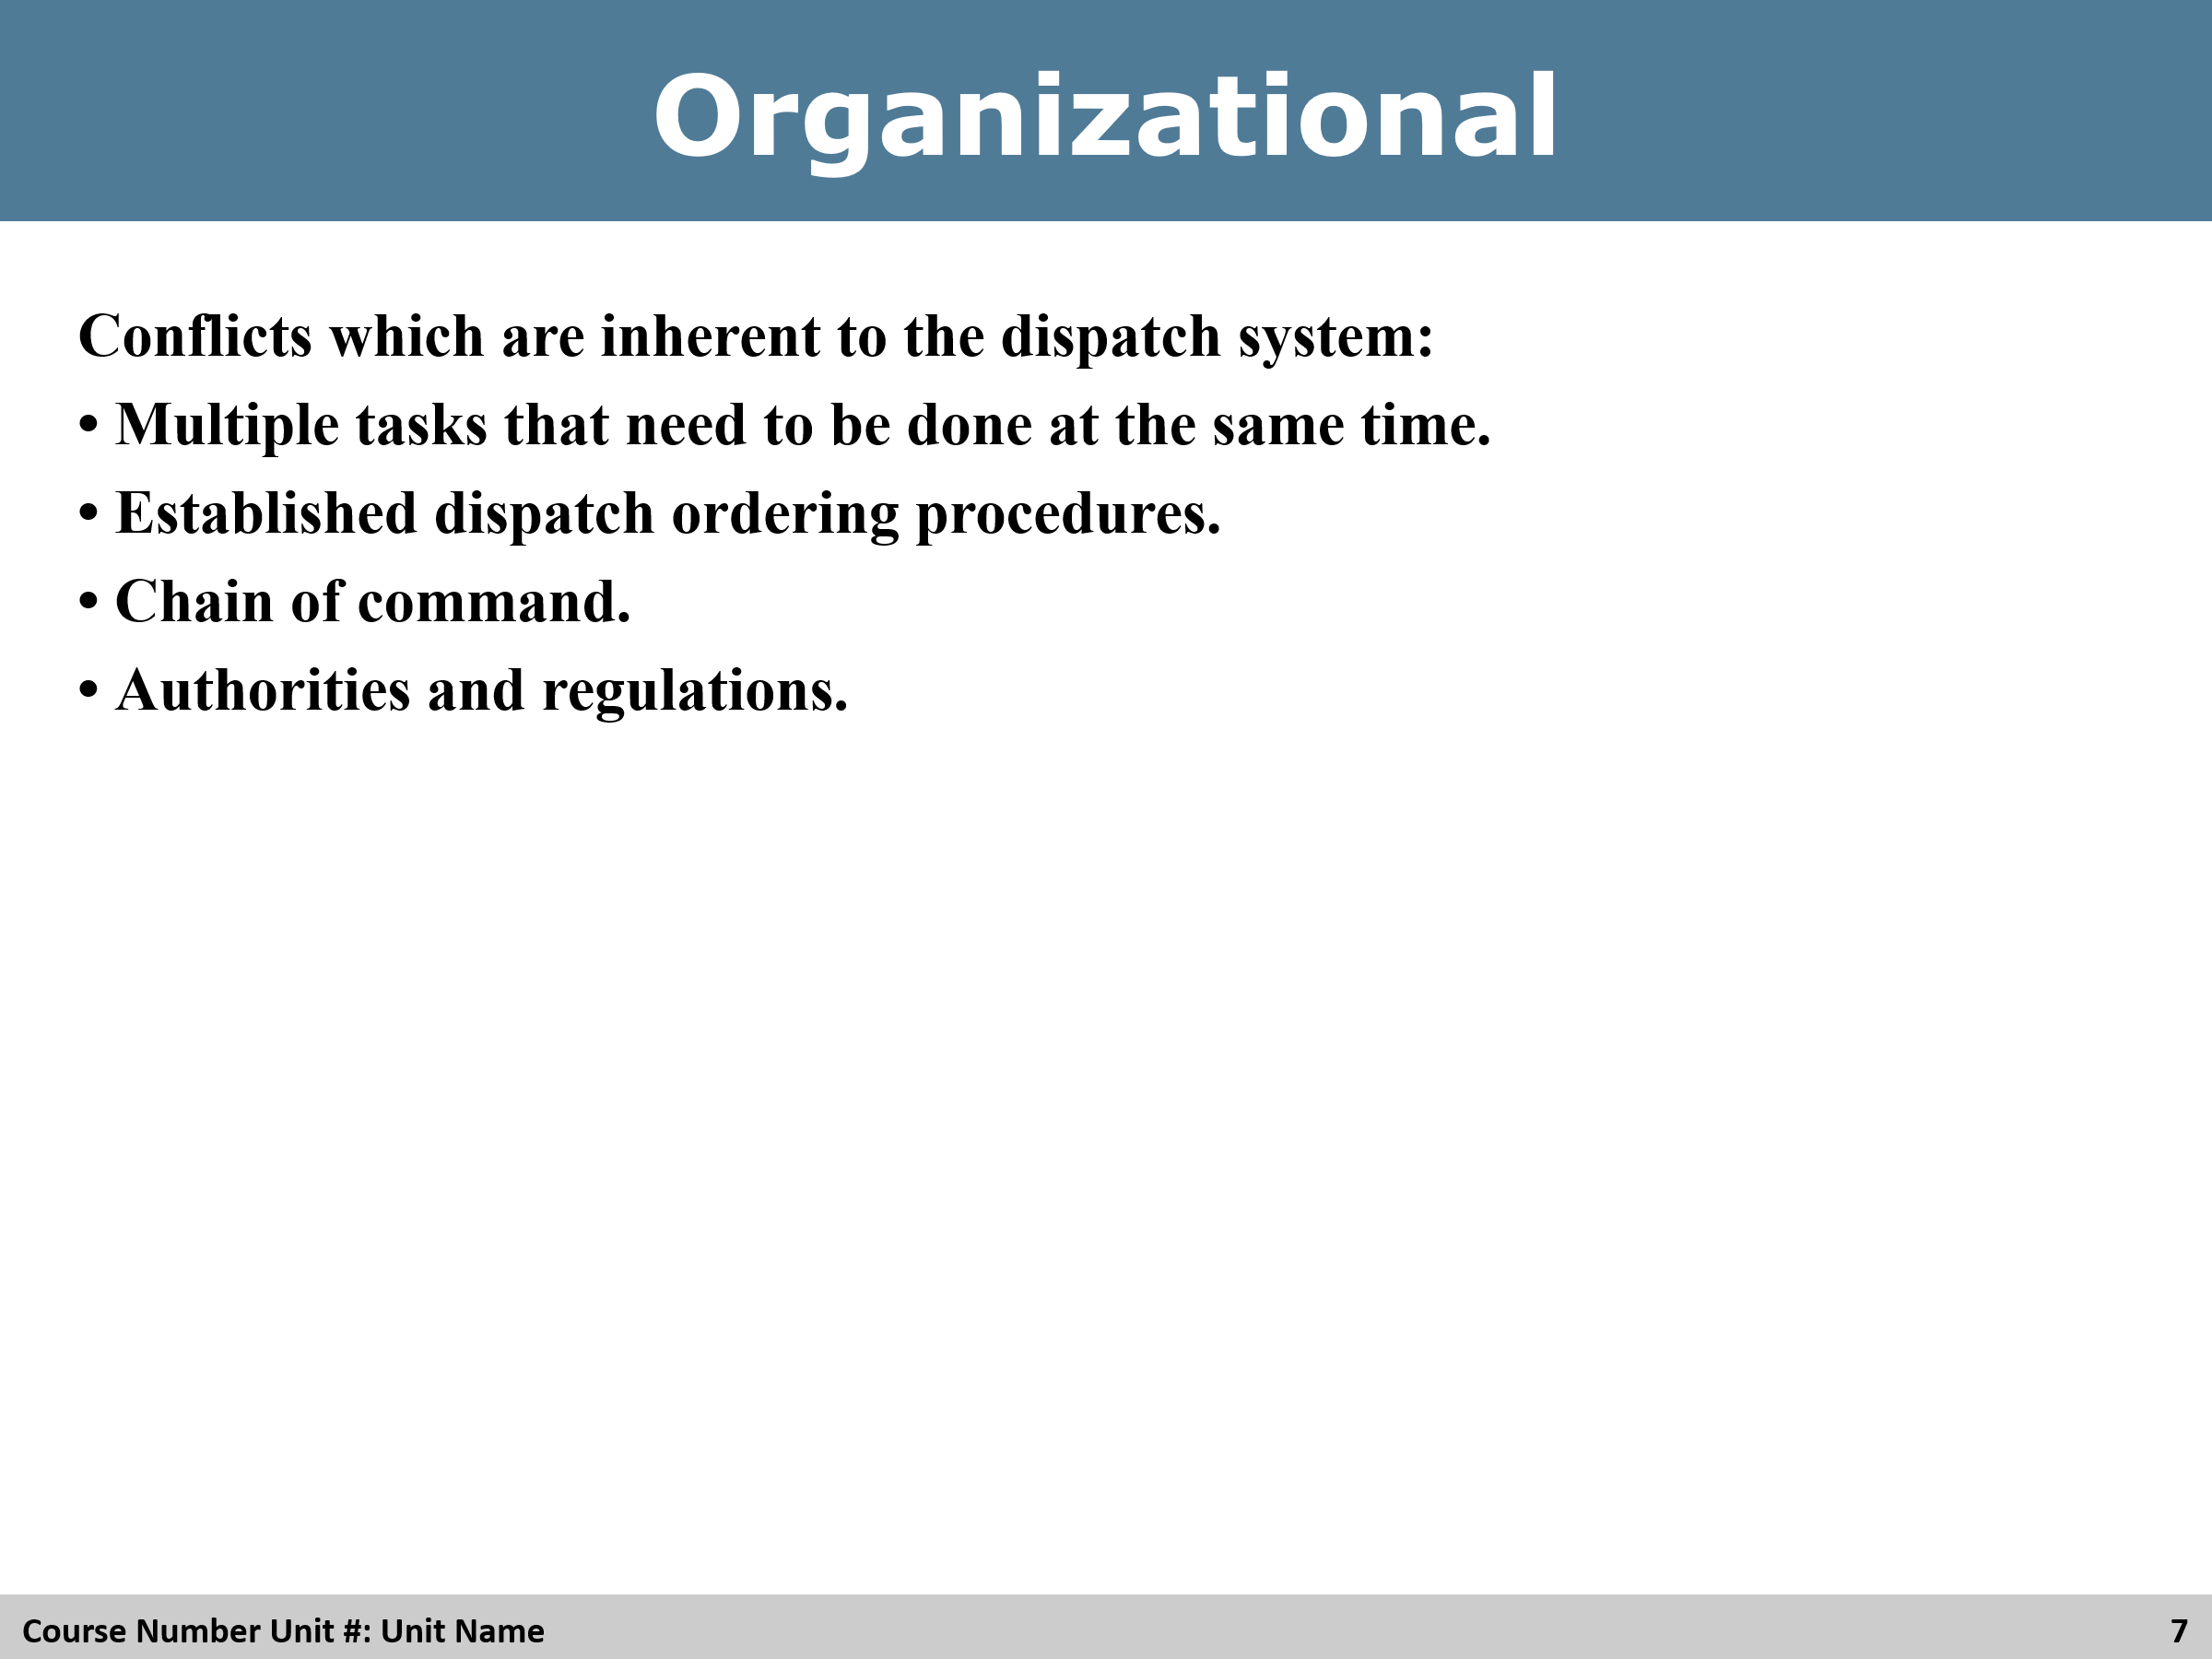

Review
Ask students for more examples.

Slide 8
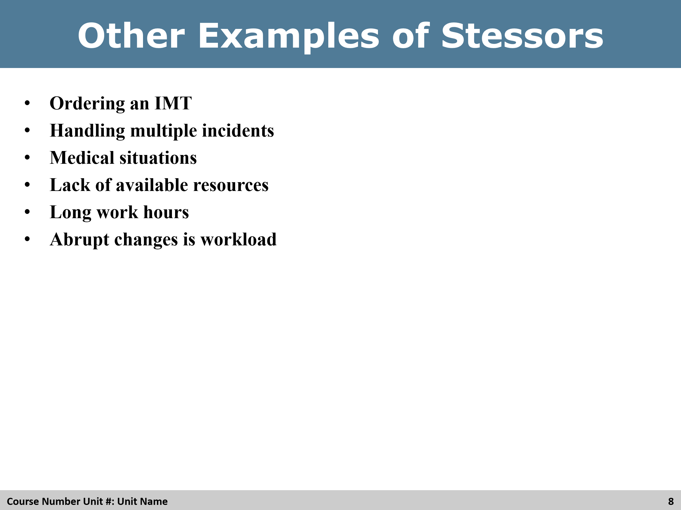

Review
Ask students for more examples.
Slide 9
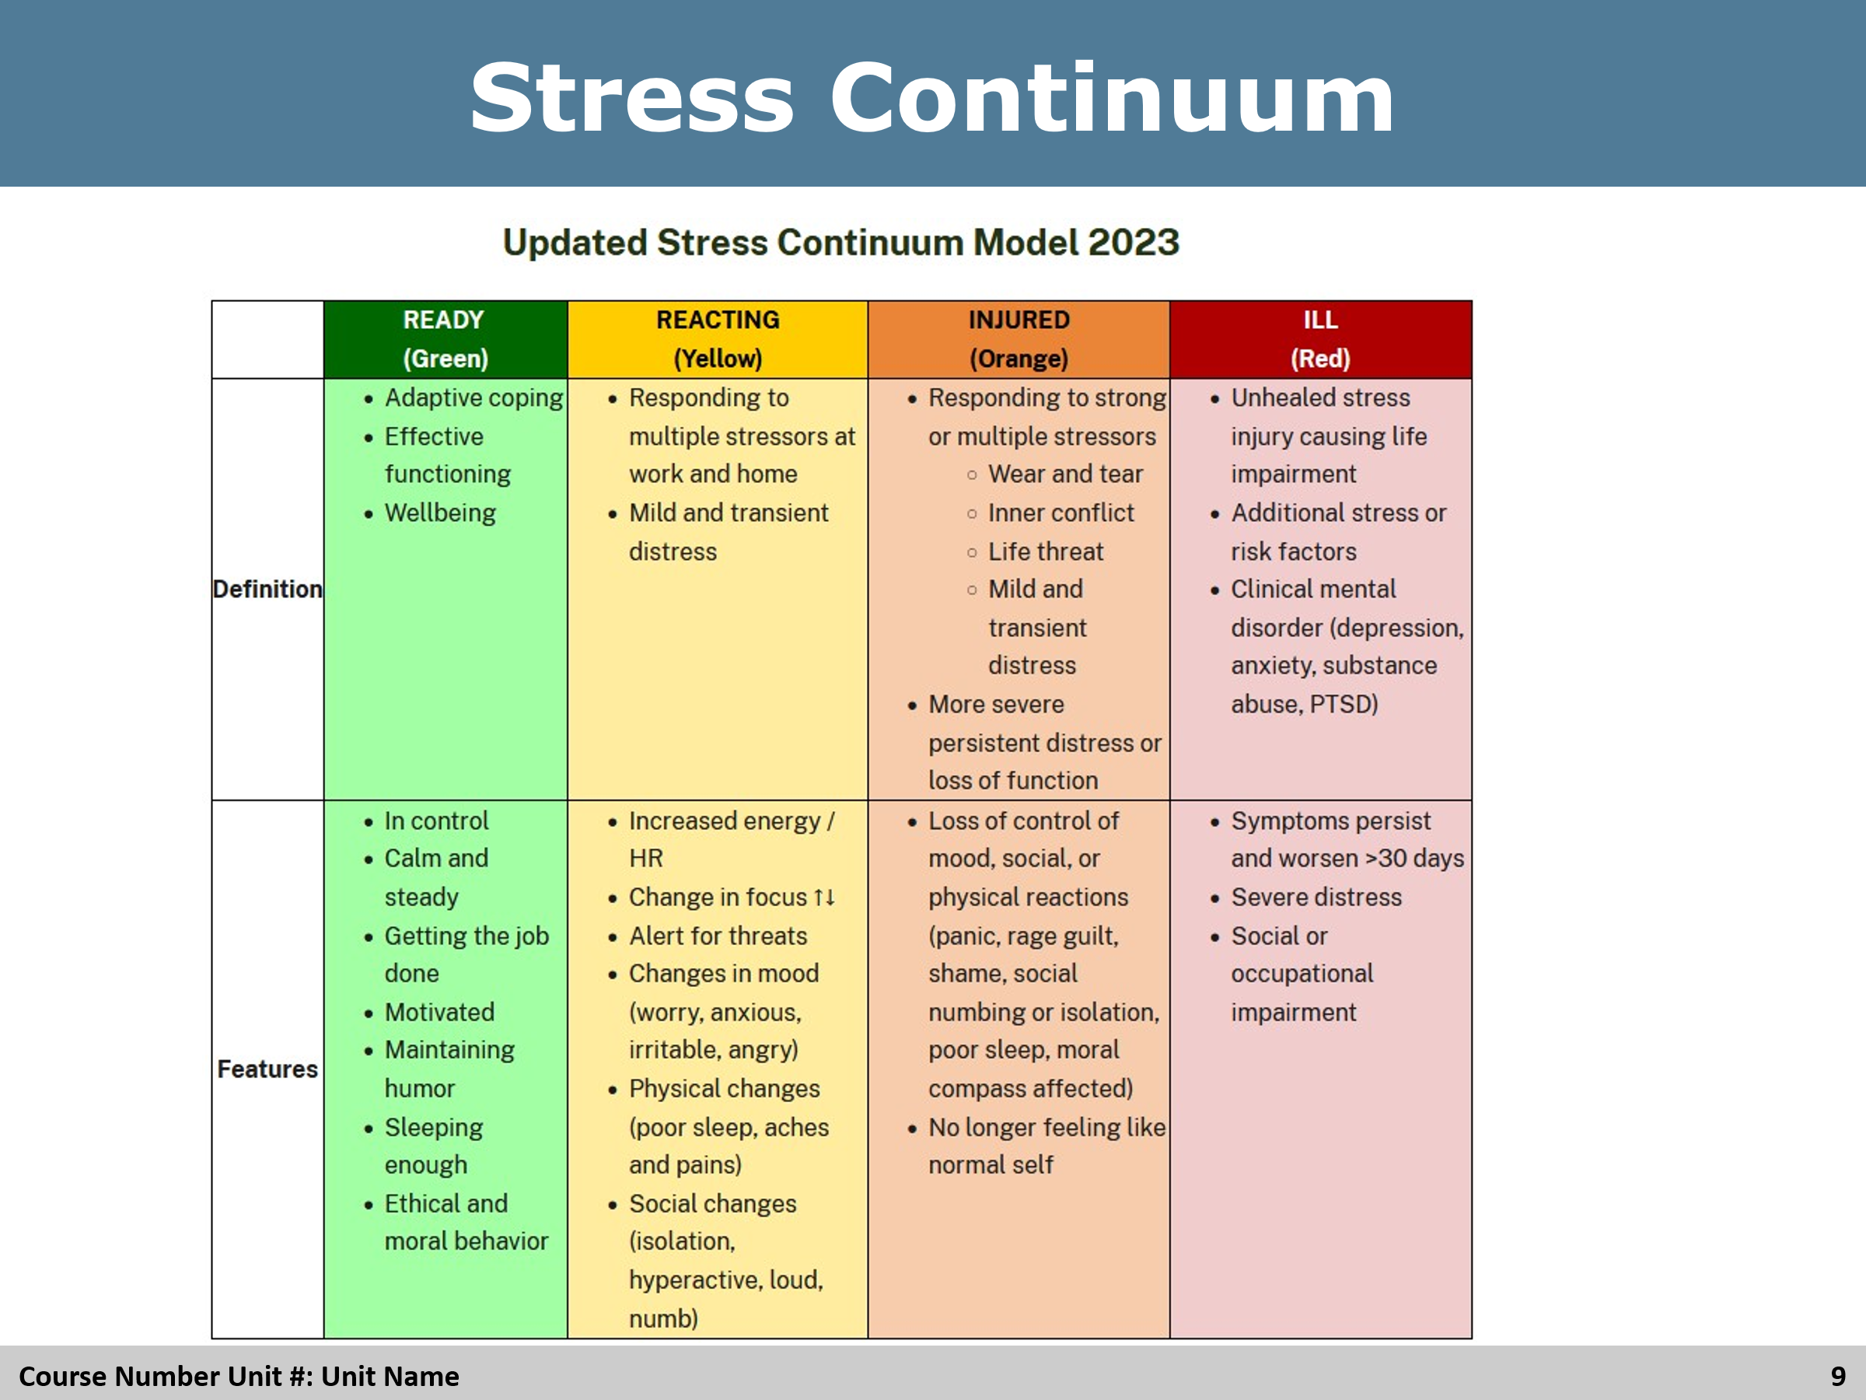

Review
Review the chart with the students.

Slide 10
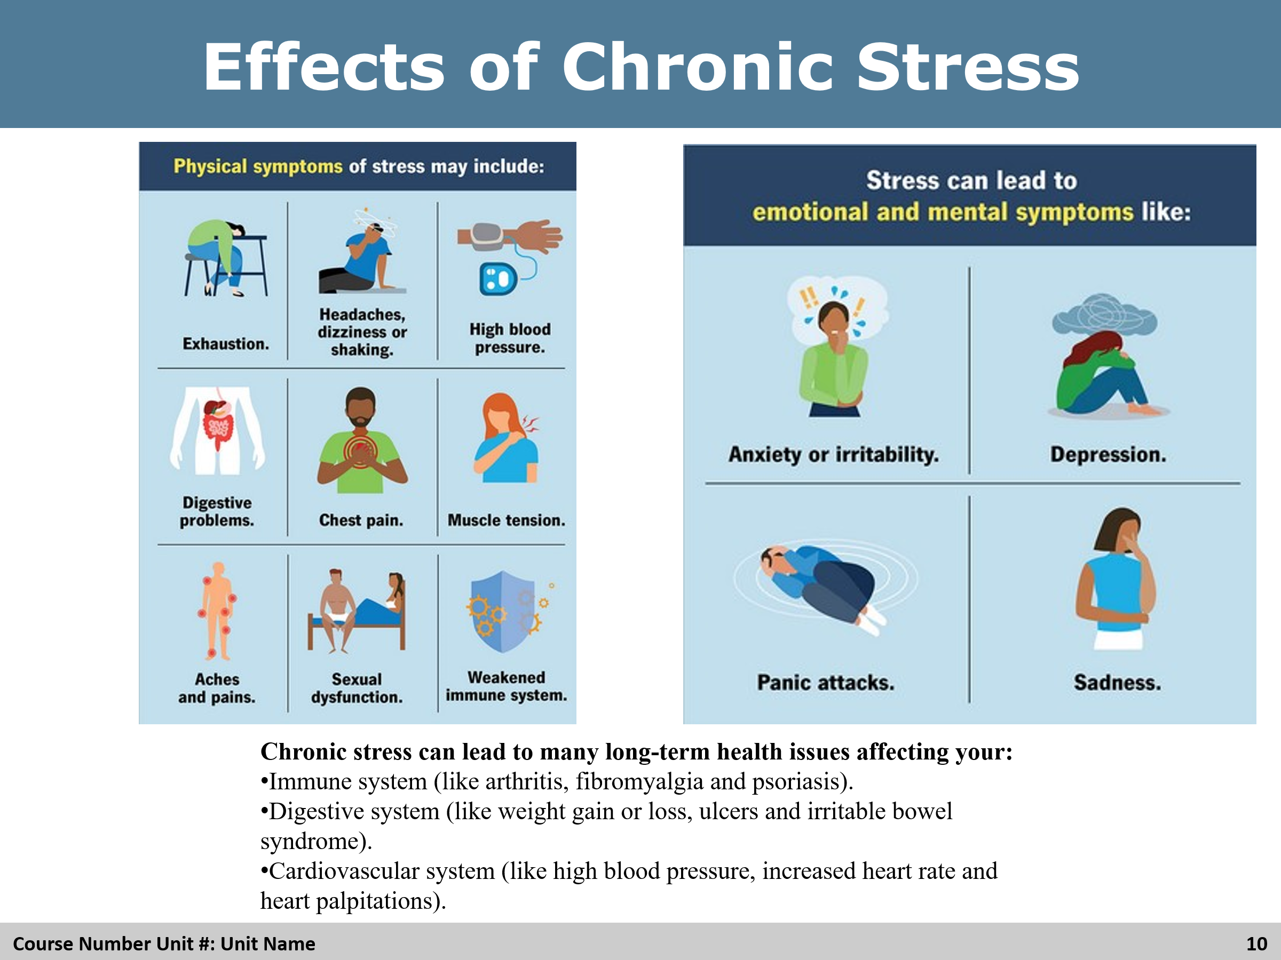

Review
Review the effects and ask the students if there are any other examples.

Slide 11
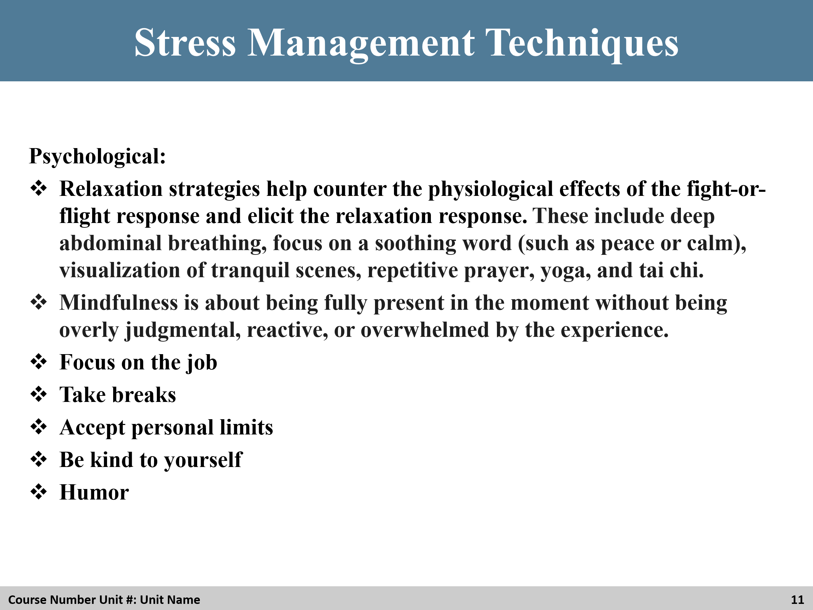

Group Discussion
Have an open discussion with this slide. Ask students if there are other techniques they use to help manage stress in their places of work.

Slide 12
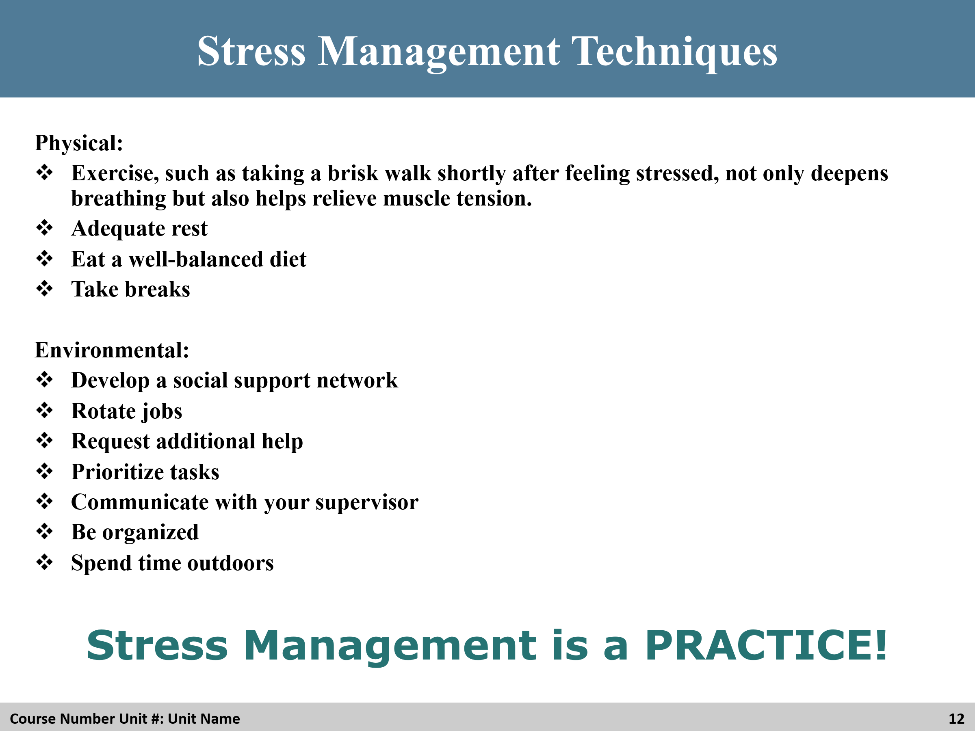

Group
Have an open discussion with this slide. Ask students if there are other techniques they use to help manage stress in their places of work.

Slide 13
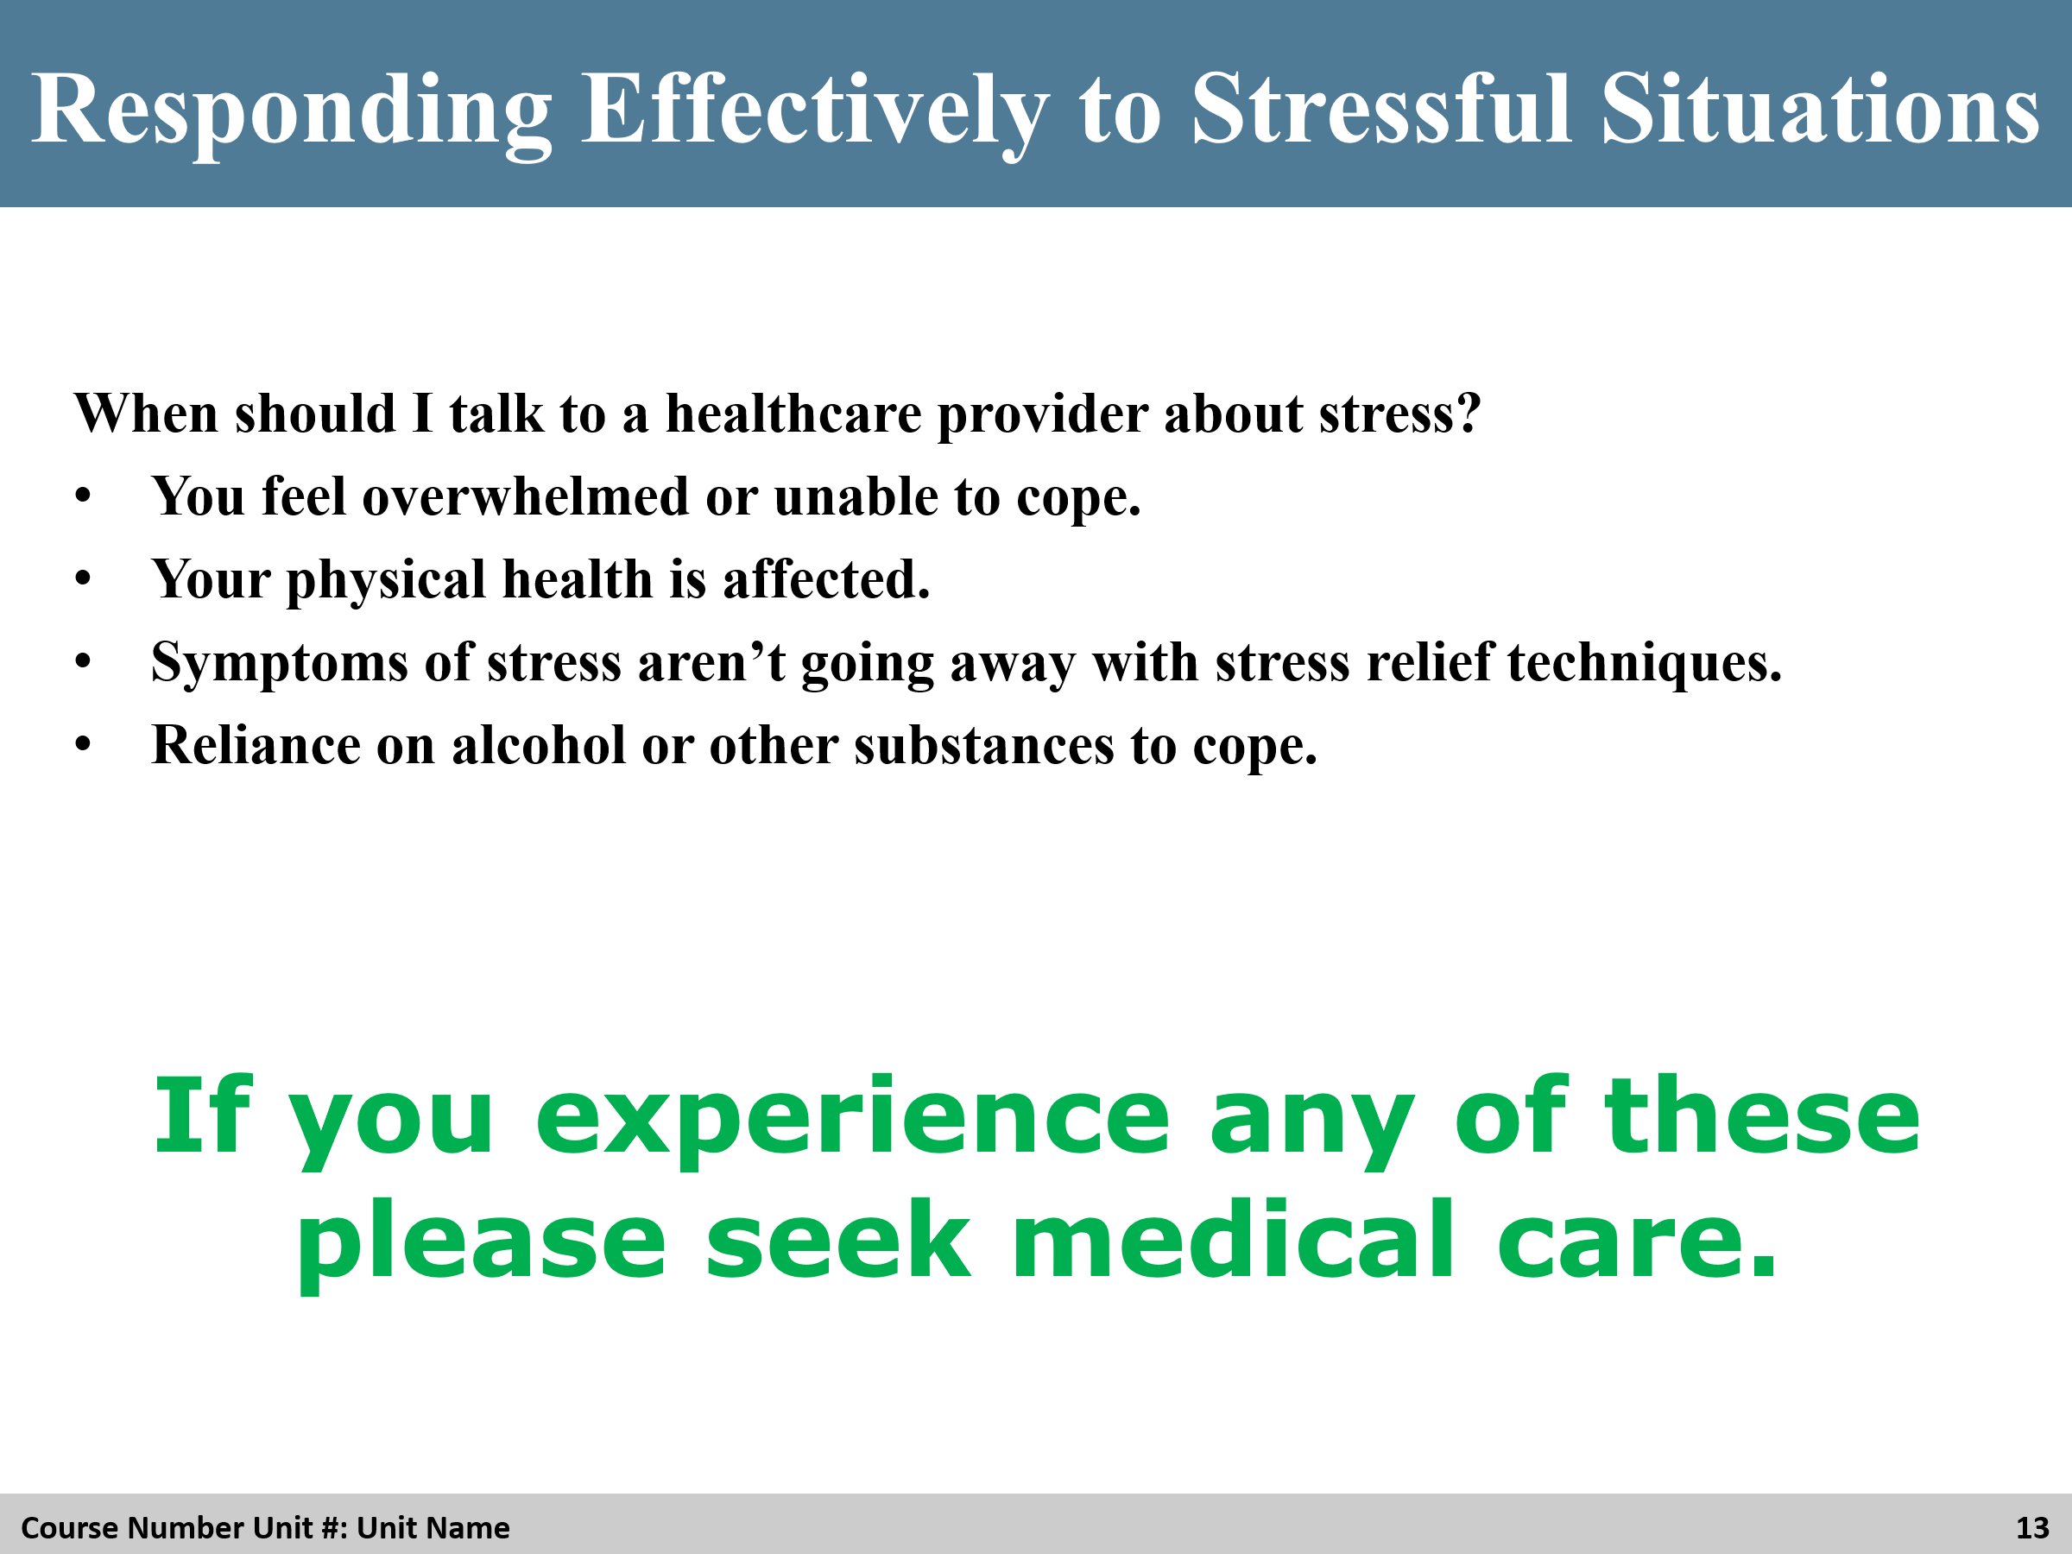

Review
Ask students for ideas of how to respond to stress

Slide 14
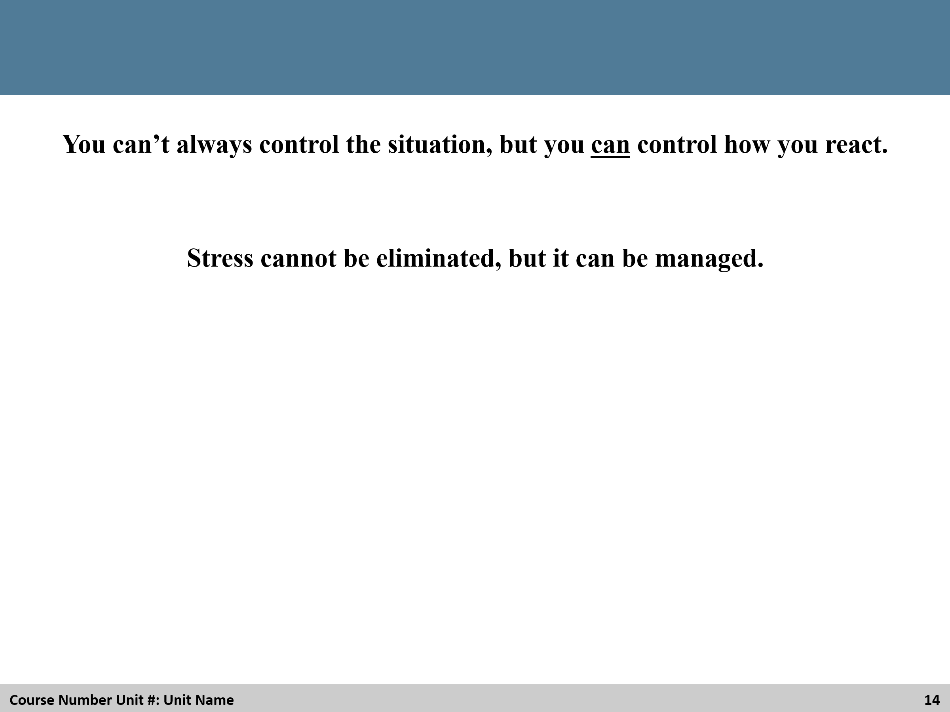

Review
Review the slide with the students.

Slide 15
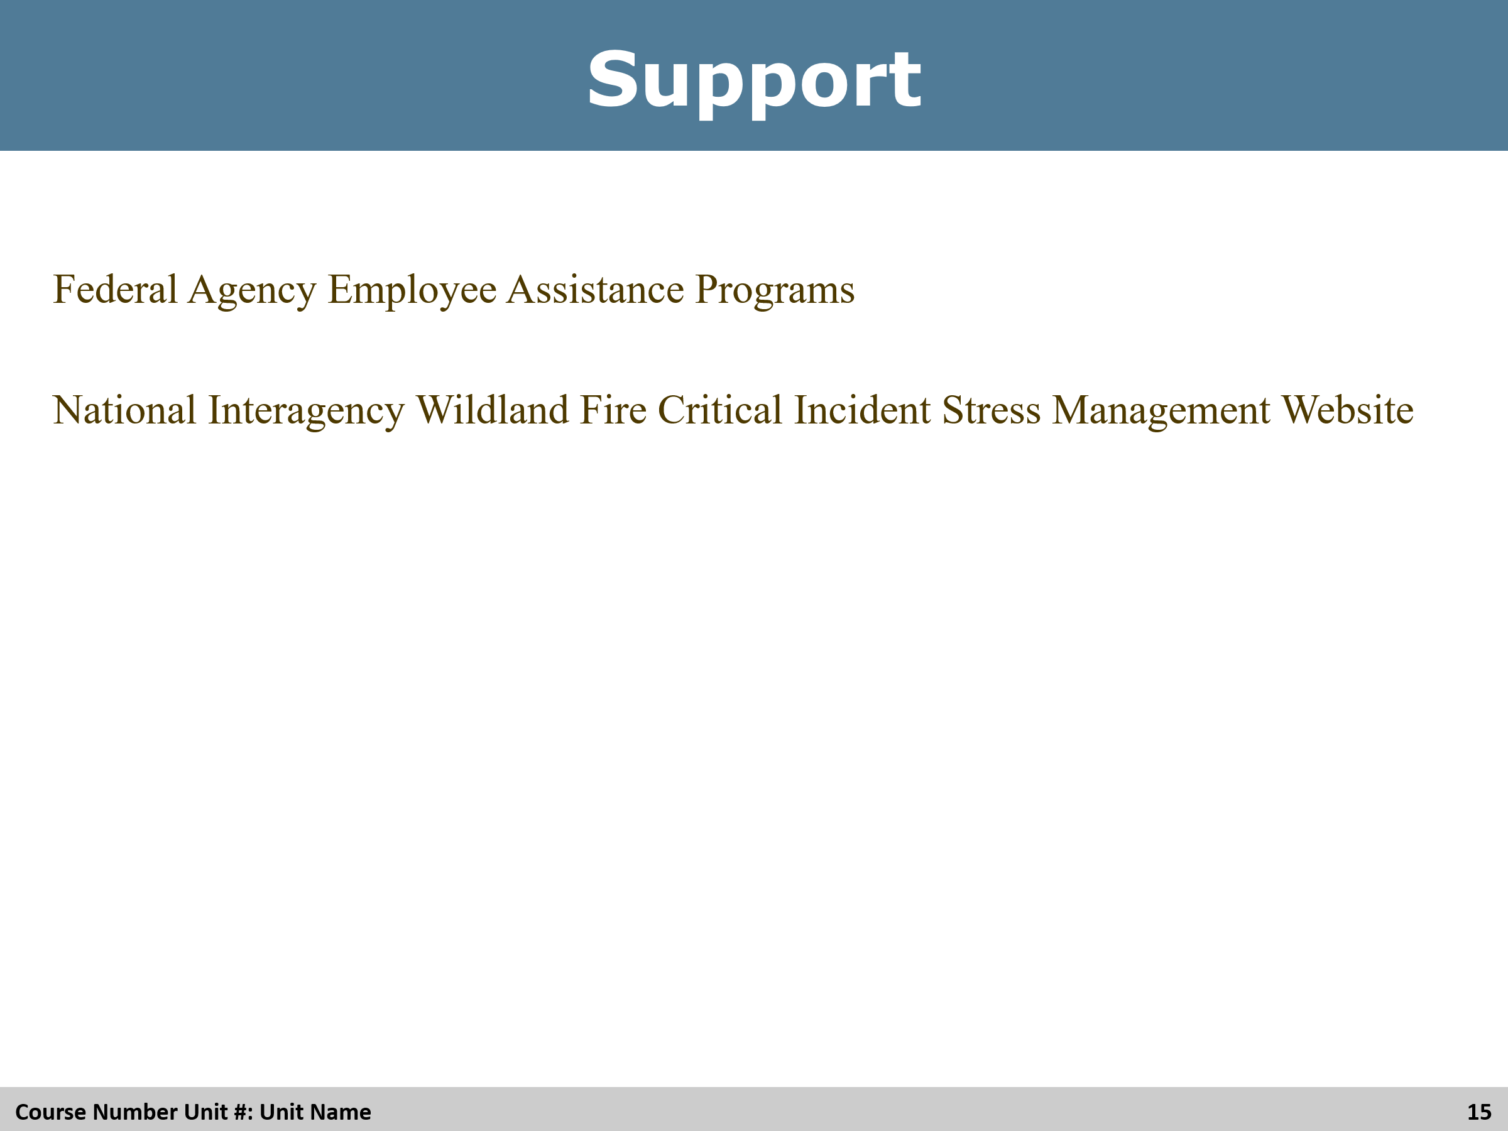

Review
Ask students if they know where to find support, have them give examples before showing the full slide.

Slide 16
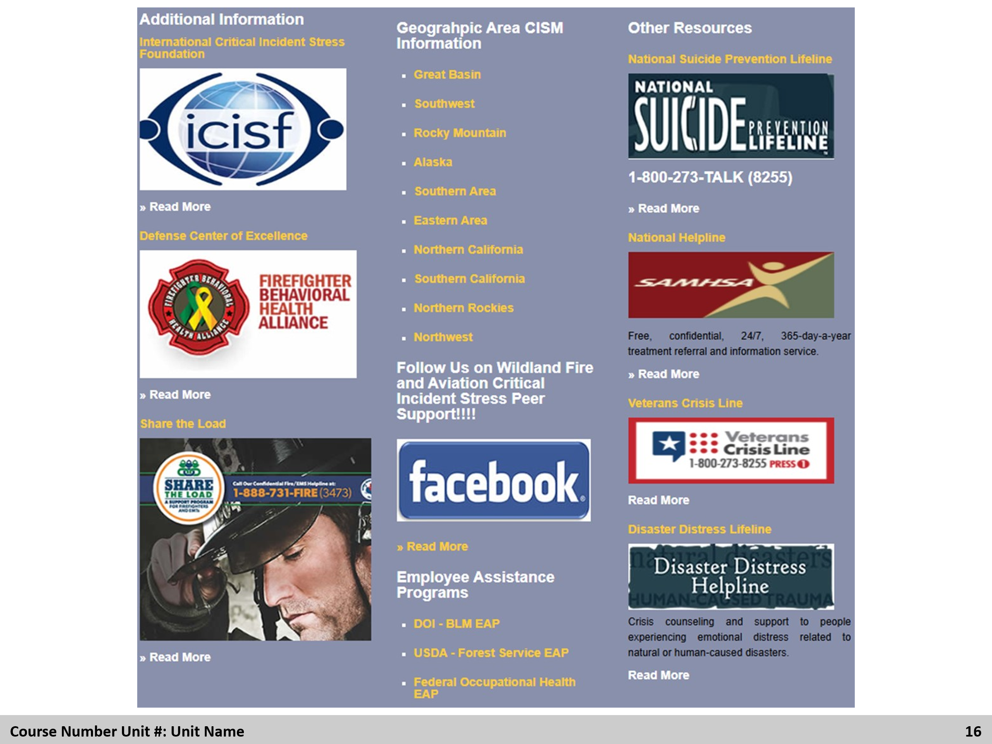
Review
Review other avenues of support. Ask students if they can give other examples that are not listed.

Slide 17
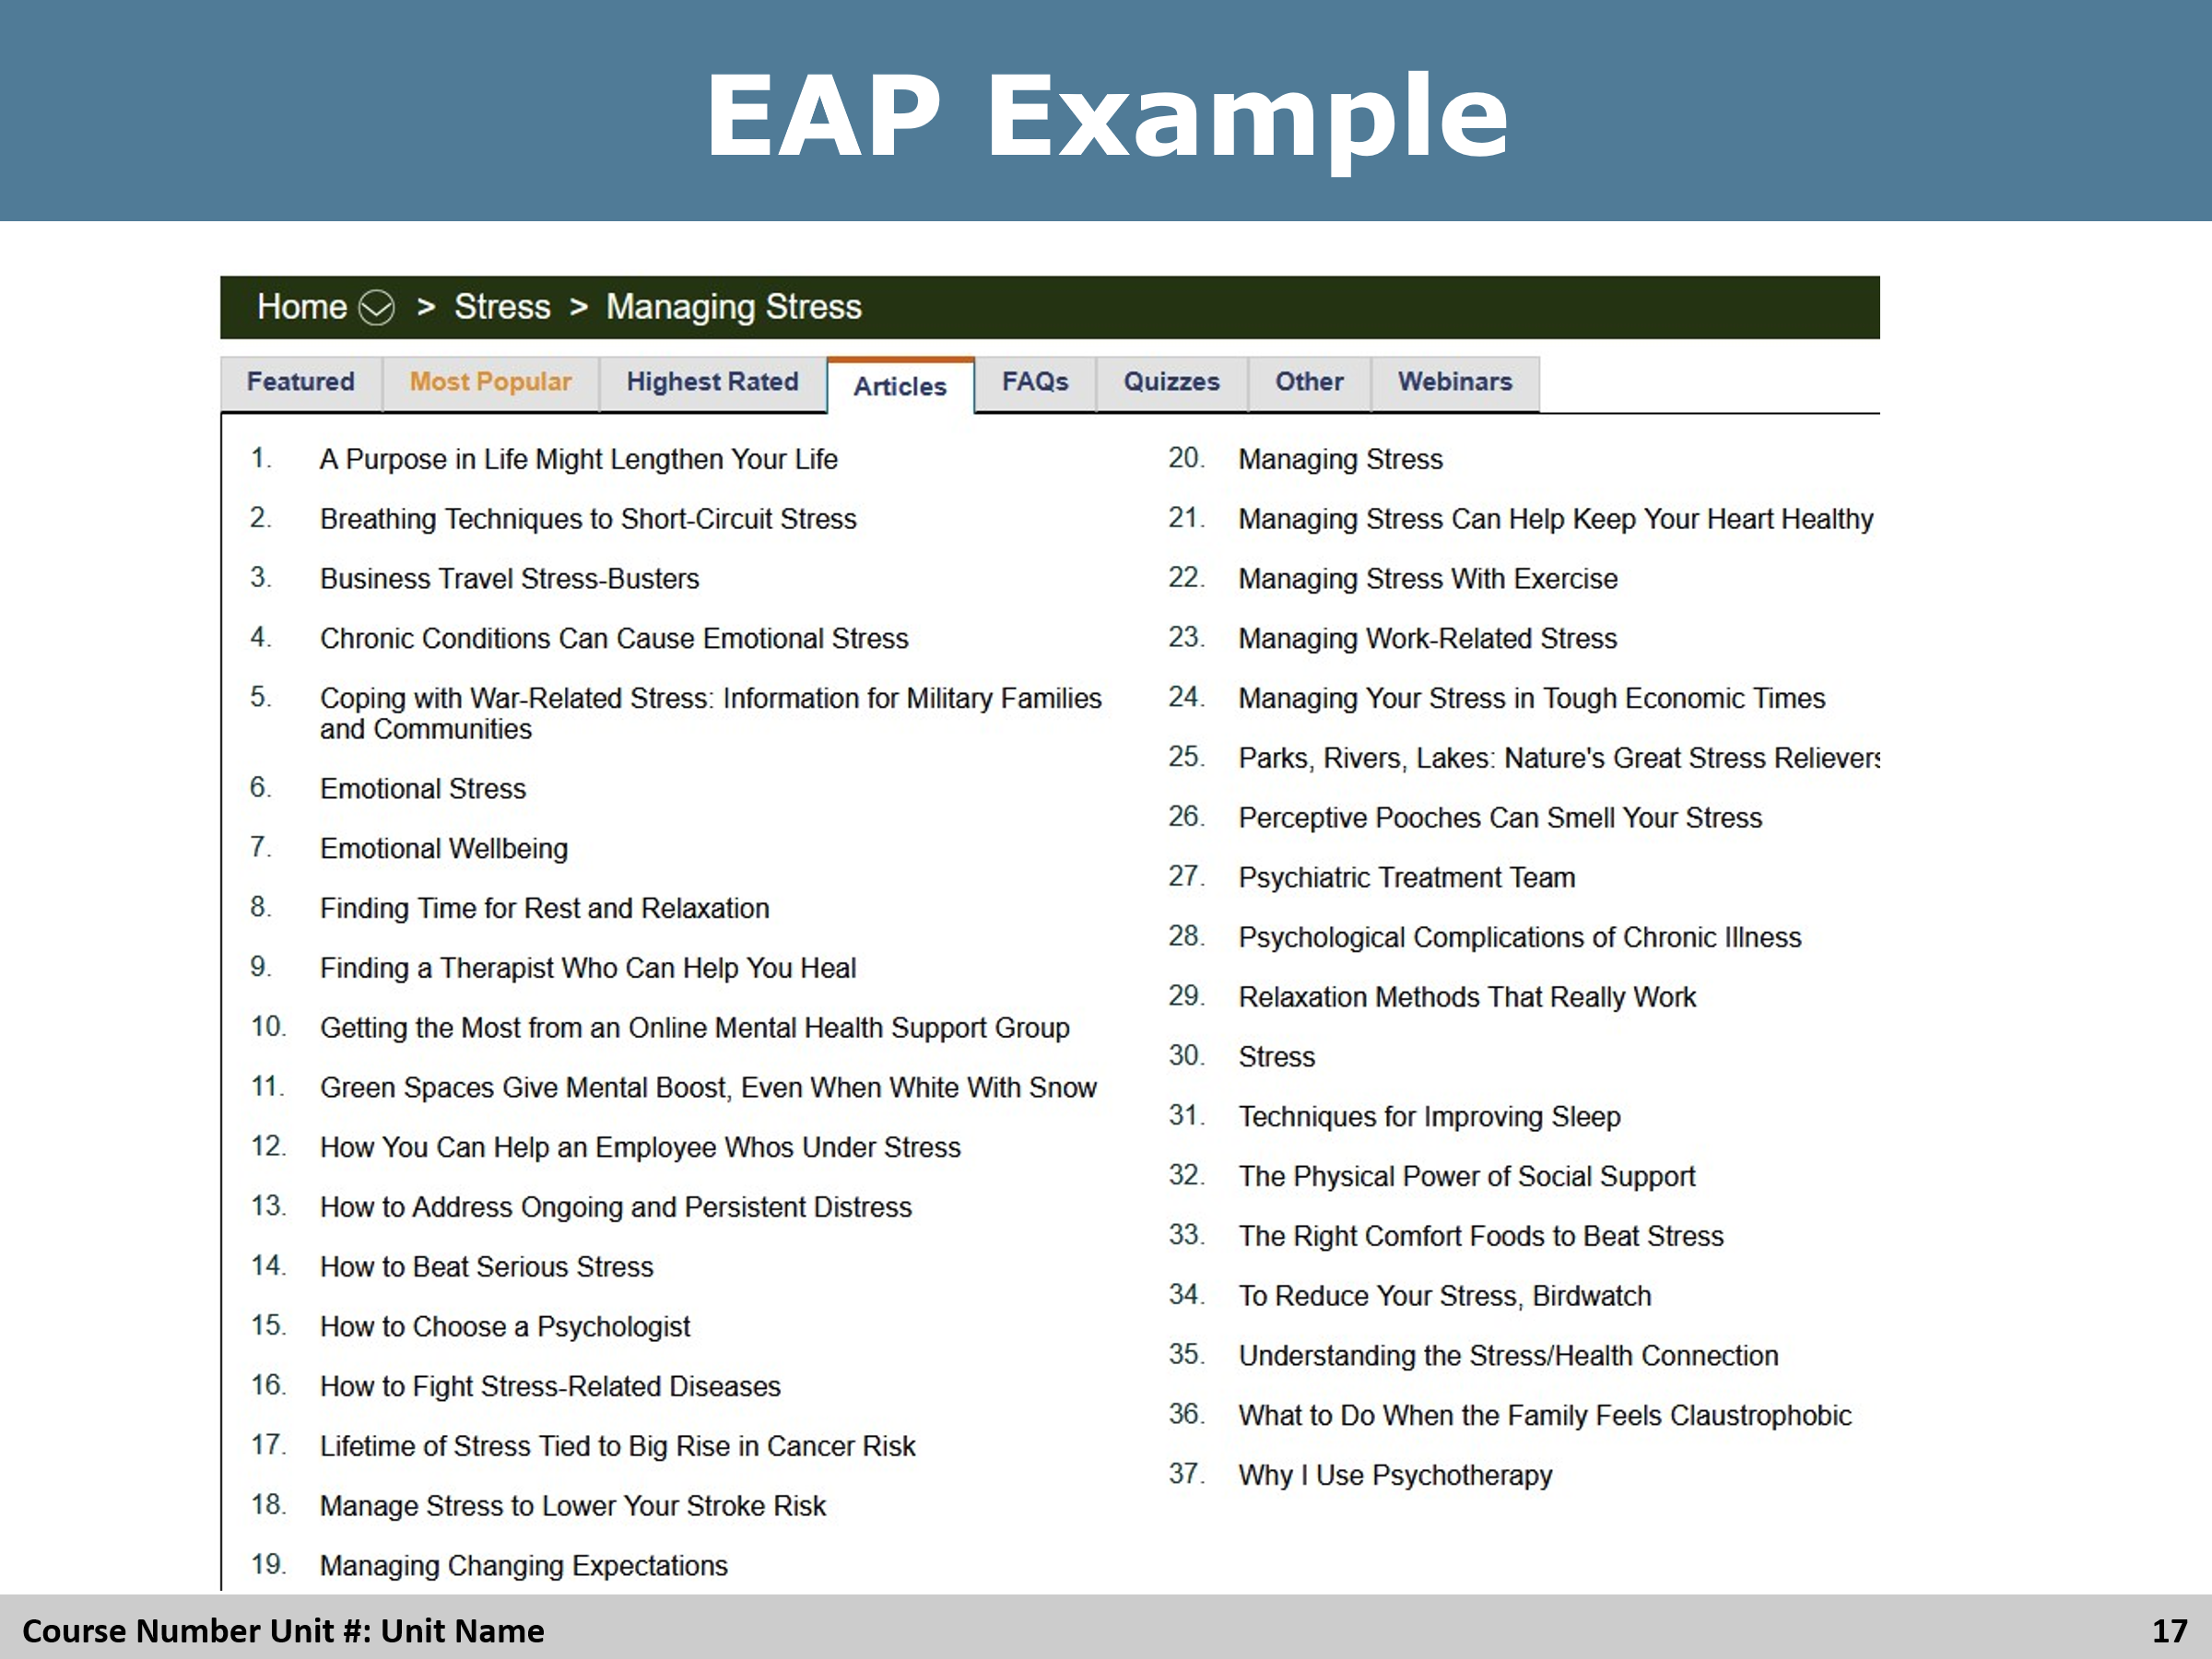

Review
Review the EAP example with the students.

Slide 18
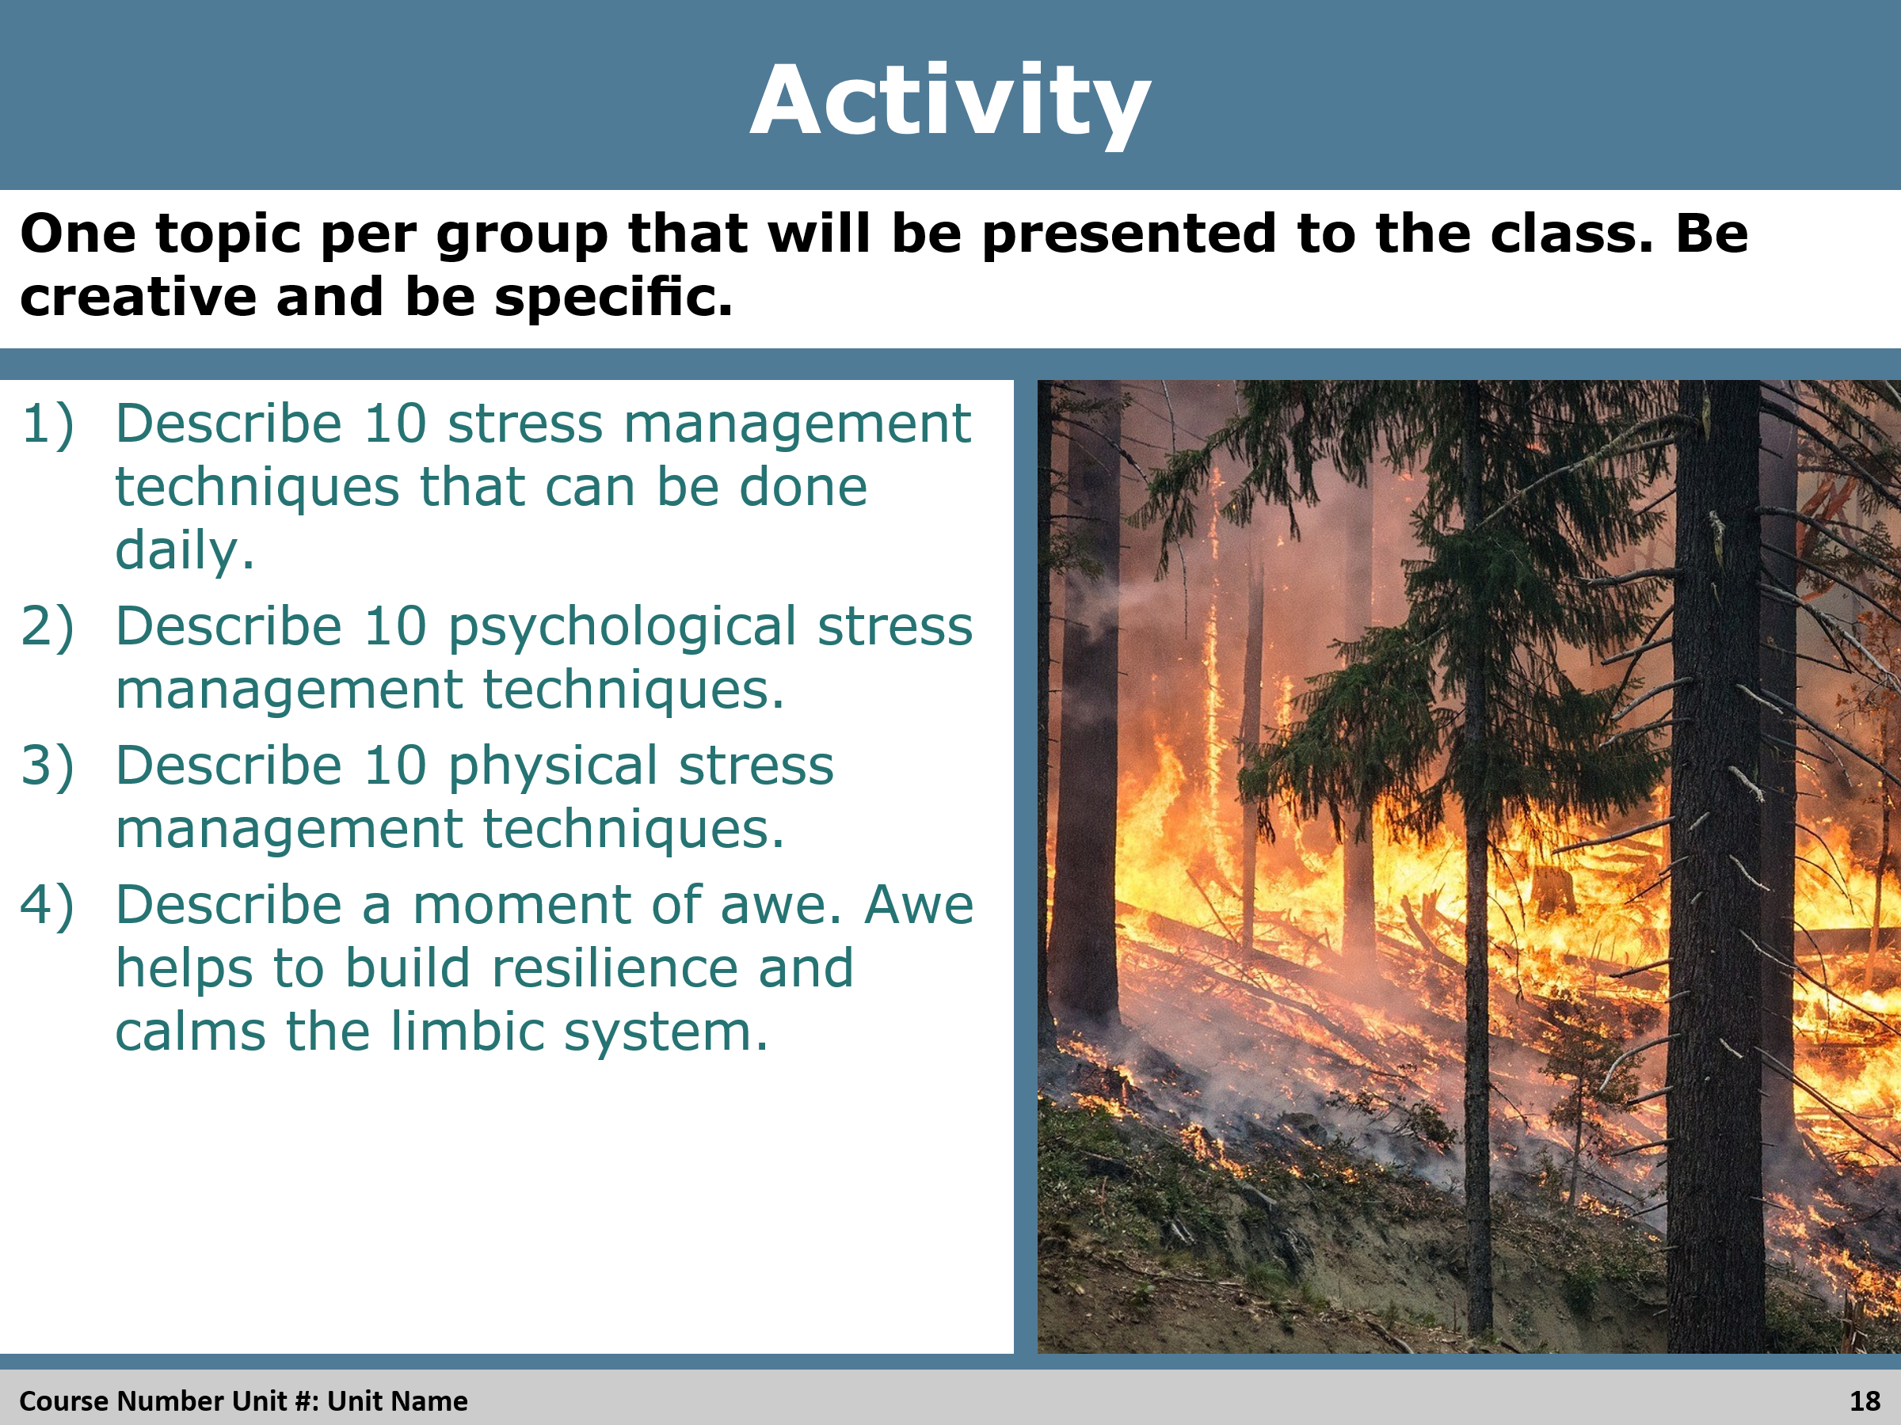

Activity
With the students in their groups, give them 15-30 minutes to work on the activity. Spend 15-20 minutes for the groups to present their answers to the whole class.

Slide 19


Review
Review the objectives again, ensure the students do not have any questions or answer questions as they come up.

Slide 20
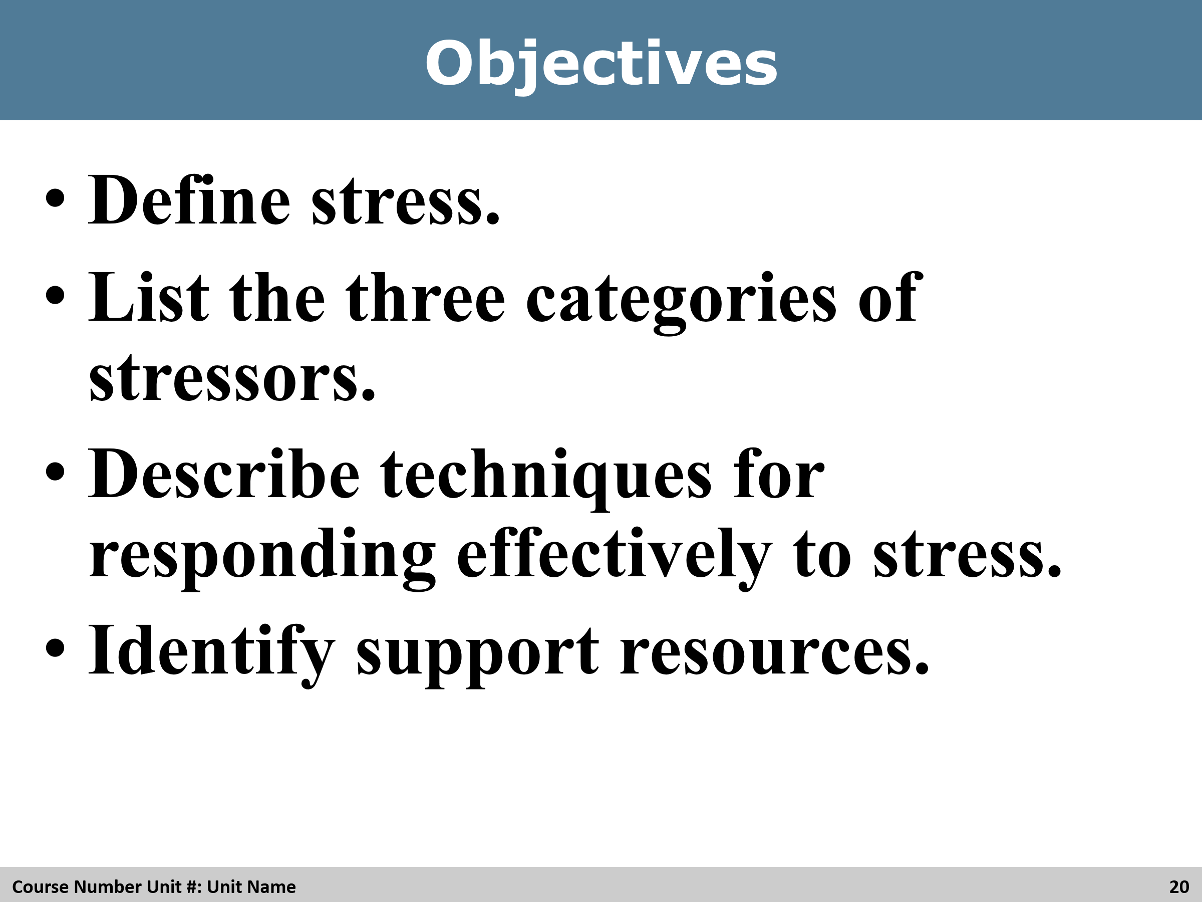

Review
Review the objectives again, ensure the students do not have any questions or answer questions as they come up.

